VISVESVARAYA TECHNOLOGICAL UNIVERSITY

JNANA SANGAMA, BELGAUM - 590014



##### A Report On

**“E Commerce Database”**

##### Submitted in the partial fulfillment for Database Management Laboratory: An Open-Ended Problem.

##### Submitted By:

**NAME (USN)**

**Akarsh Singh 1SI16CS007**

**Akshat Agarwal 1SI16CS010**

**Under the guidance of:**

**Mr. V Ravi Mrs. Thejaswini S**

**(Assistant Professor) (Assistant Professor)**



#### DEPARTMENT OF COMPUTER SCIENCE AND ENGINEERING

SIDDAGANGA INSTITUTE OF TECHNOLOGY, TUMKUR-572103

(An Autonomous Institute, Affiliated to Visvesvaraya Technological University, Belgaum, Recognized by AICTE and Accredited by NBA, New Delhi)

**2018-2019**

**ACKNLOWLEDGEMENT**

We consider this as a privilege to express a few words of gratitude to all those who guided and inspired us for the successful completion of our project work

We are thankful to God for giving us an opportunity to associate ourselves with an esteemed personality like his Holiness **Dr. Sree Sree Sivakumaraswamigalu** and **Sri Sri Siddalinga Swamiji**, who has been a great inspiration and guidance to all of us.

We express our gratitude to our respected Director, **Dr. M.N Channabasappa** for his constant support in fulfilling our endeavors.

We would also like to thank our respected Principal, **Dr. K P Shivananda** for providing us with various facilities for carrying out this project.

We are also thankful to **Dr. R Sumathi**, Professor and Head, Department of Computer Science and Engineering for giving us all the freedom, inspiration and encouragement to carry out this project successfully.

We thank our project guide **Mrs. S. Thejaswini**, Assistant Professor, Department of Computer Science and Engineering and **Mr. V Ravi,** Assistant Professor, Department of Computer Science and Engineering for providing the critical support on every step of this project development. Their guidance gave us the environment to enhance our knowledge, skills and to reach the pinnacle with sheer determination, dedication and hard work. Without their aspiring support this project would not have been implemented.

Lastly, we thank our anonymous reviewers for their insights. We are also immensely grateful to them for their comments during the development of project. Any errors are our own and should not tarnish the reputation of these esteemed persons.

**SIDDAGANGA INSTITUTE OF TECHNOLOGY**

**TUMKUR-572103**

# *DEPARTMENT OF COMPUTER SCIENCE AND ENGINEERING*



**CERTIFICATE**

This is to certify that the Open-ended experiment in DATABASE MANAGEMENT SYSTEM Laboratory(6CSL01) “E COMMERCE DATABASE” has been successfully carried out by **AKARSH SINGH** bearing **USN 1SI16CS007** and **AKSHAT AGARWAL.** bearing USN **1SI16CS007** at Siddaganga Institute of Technology, Tumkur, in partial fulfilment of the requirements for 6th Semester of Bachelor of Engineering in Computer Science and Engineering of Visvesvaraya Technological University, Belgaum, during the academic year 2018-2019. It is certified that all corrections/suggestions indicated have been incorporated in the report. The experiment has been approved, as it satisfies the academic requirements in respect of Open-ended work prescribed for the Bachelor of Engineering Degree.

Evaluation Form (Rubrics)

|  |  |  |  |  |
| --- | --- | --- | --- | --- |
| Quality of problem selected  (5M) | No of concept used in solution  (Implementation Quality)  (5M) | Quality of Report (Format and details)  (5M) | Total Marks  (15) | Points(5M)  (Total marks/3=5) |
|  |  |  |  |  |

Signature of Faculty-In Charge

1. Mrs. S Thejaswini

2. Mr, V Ravi

**CONTENT**

**ABSTRACT**

This is a small-scale project for Online Shopping System. The basic idea is that, the customers can buy the products online. The customers can enter their credentials and create an account to browse through or buy the listed products.

The Online Shopping System enables the vendors to setup online shops, list the products on the website and sell them. The agenda is to design an online shopping website to manage the items in the shop and help the customers purchase them online without having to visit the shop physically. Our Online Shopping System will use the internet as a sole method for selling the goods to its customers.

The website enables the owner to list their product online for sale. It also contains a cart which hold the shortlisted products which the customer wants to buy. It also includes product and customer management modules.

**INTRODUCTION**

The aim of this project is on the online shopping application which is developed using the front-end tools like HTML and CSS. The application is useful as the customers can buy the products listed by the seller in a very short amount of time and without the need of physically going to the shop to buy the products. The application intends to reduce the workload of the customer as well as the seller. The sale and purchase transaction are  
completed electronically and interactively in real- time. The development of this new system contains the following activities, which try to develop online application by keeping the entire process in the view of database integration approach. User uses its email id and password to access their account.

**Administrator** of Online Shopping System has multiple features such as Add, Delete and Update shopping items.

**Some of the salient features of the Online Shopping System are:**

* Secure registration and profile management facilities for the customers.
* Browsing through the e-Mall to see the items that are listed under each category of products like Apparel, Kitchen accessories, Bath accessories, Food items etc.
* Creating a Shopping cart so that customer can shortlist the items of and finally checkout with the desired products.

**CHAPTER 2**

**REQUIREMENT SPECIFICATION**

* 1. **Requirements**
     1. **Hardware Requirements**

Processor : Intel Core i3

Hard Disk : 40 GB

RAM : 1 GB or more

* + 1. **Software Requirements**

Operating System : Windows 7 or above / Linux

User Interface : HTML, CSS

Back-end : PHP

Database : Oracle SQL 11g

Server Deployment : Xampp

* 1. **Entities and their Attributes**

|  |  |  |  |  |  |  |  |
| --- | --- | --- | --- | --- | --- | --- | --- |
| CUSTOMER | CustomerID | CustomerName | Password | Email | State | City | State |
| ORDER | OrderID | OrderDate | Amount |  |  |  |  |
| ORDER DETAILS | Quantity | Status |  |  |  |  |  |
| SUPPLIER | Location | Supplier Name | SupplierID |  |  |  |  |
| PRODUCT | Product ID | Product Name | Price |  |  |  |  |
| CATEGORY | CategoryID | CategoryName |  |  |  |  |  |

* 1. **Relationship Types**

|  |  |
| --- | --- |
| Relationship | Type |
| PLACES | 1: N |
| HAS | 1:1 |
| CONTAINS | N:1 |
| BELONGS TO | N:1 |
| SUPPLIES | M: N |

**CHAPTER 3**

**CONSTRAINTS**

**CHAPTER 4**

**DESIGN**

* 1. **E-R Diagram**

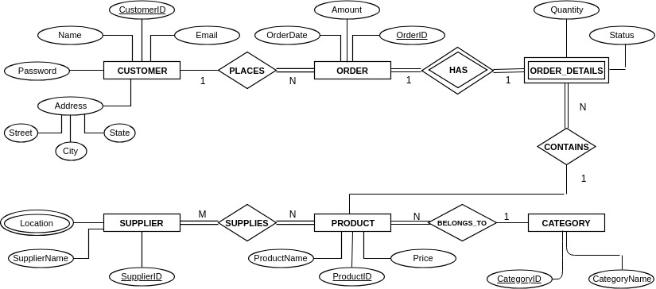

* 1. **Relation Schema Diagram**

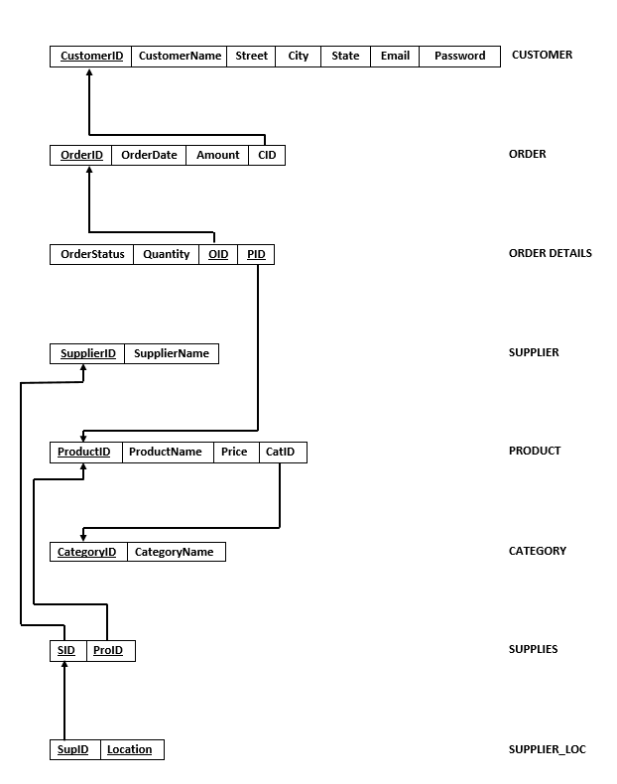

**CHAPTER 5**

**IMPLEMENTATION**

* 1. **Front End Tool**
  2. **Back End Tool**
  3. **Create Table Queries**

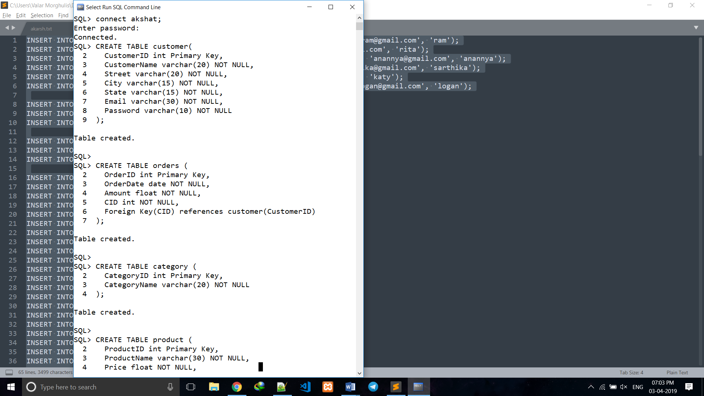

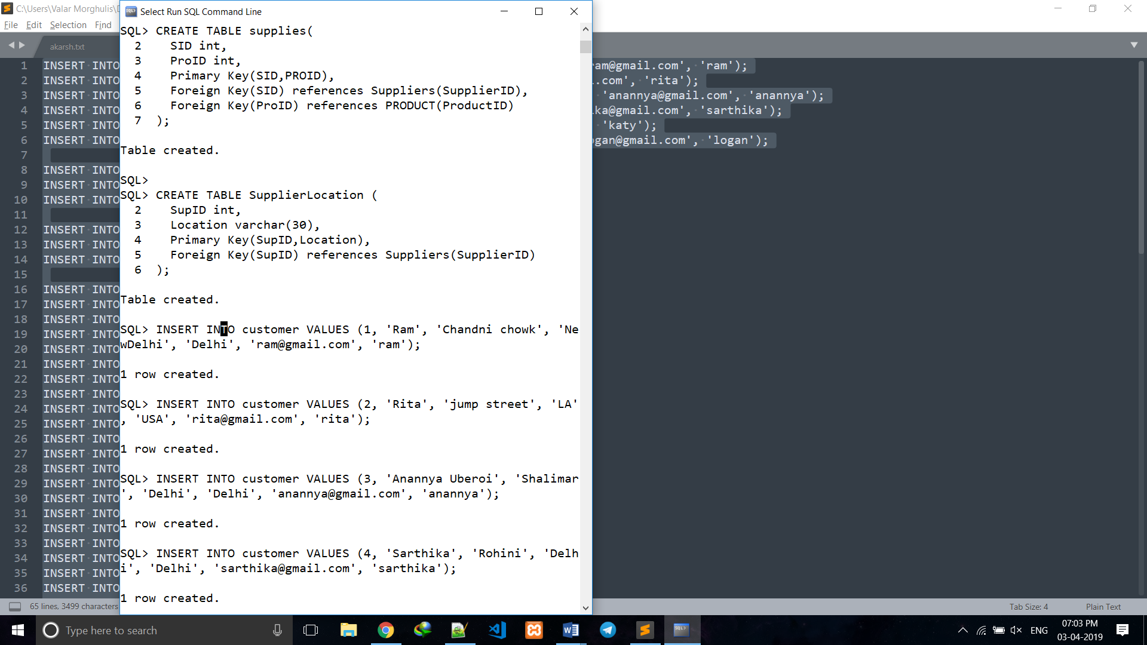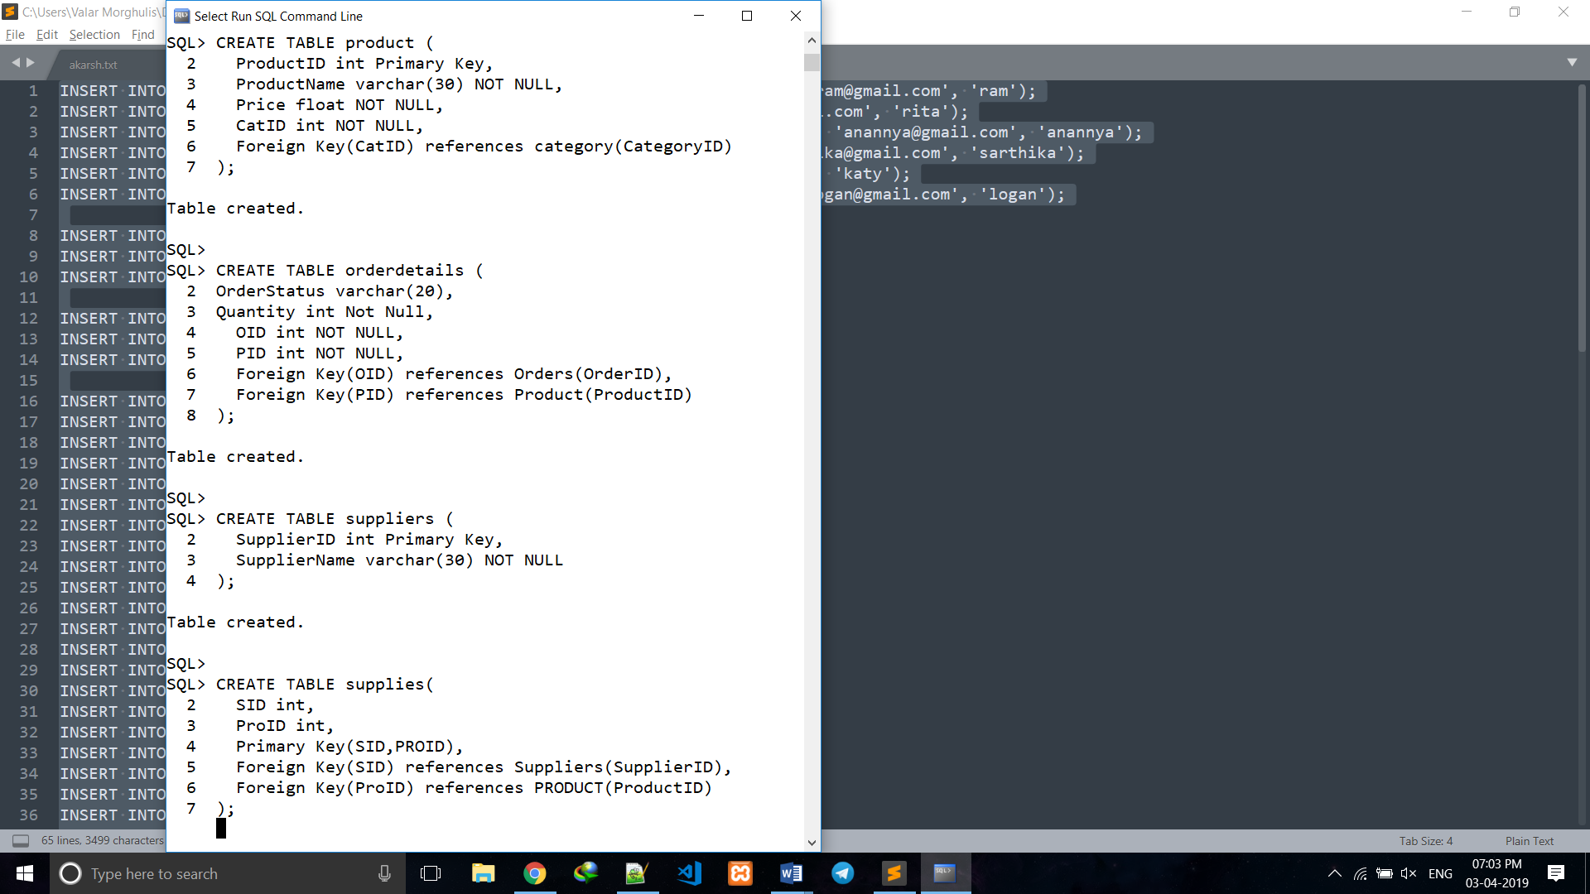

* 1. **Insert Queries**

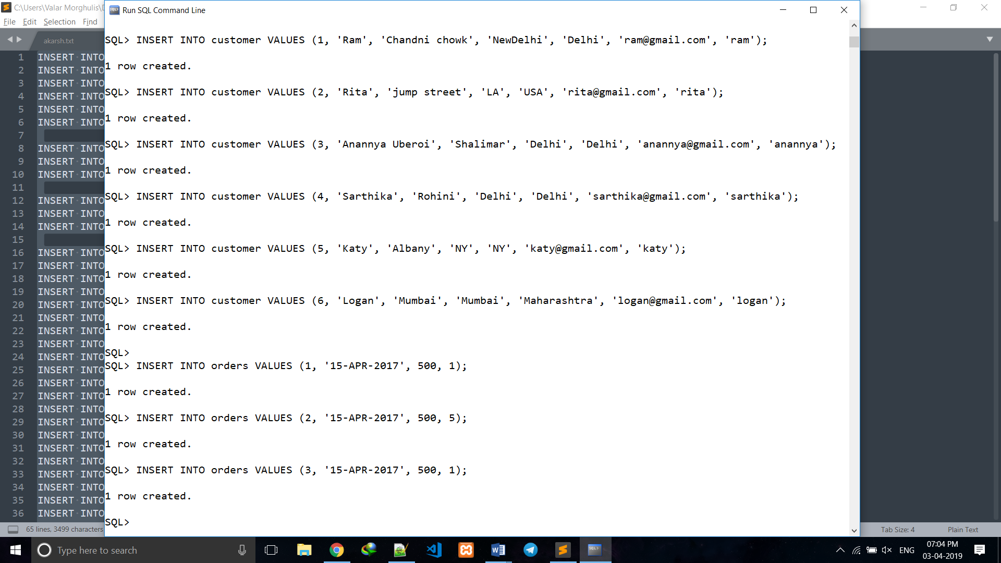

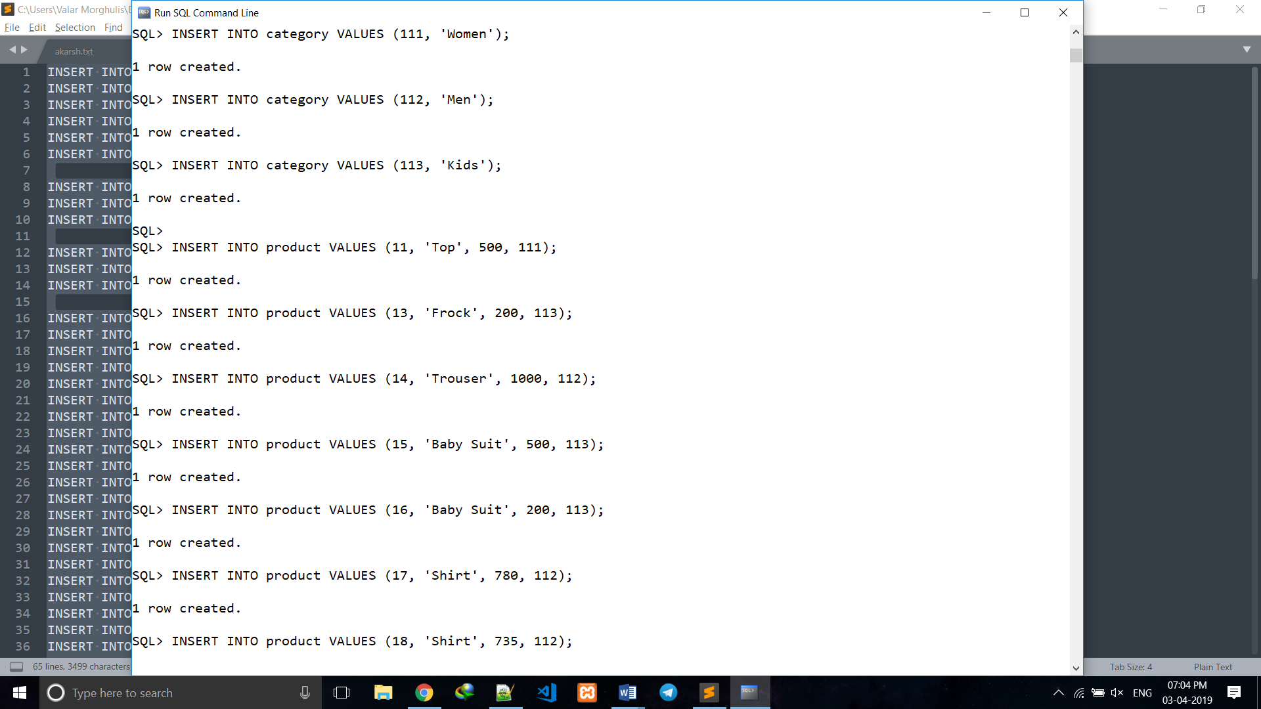

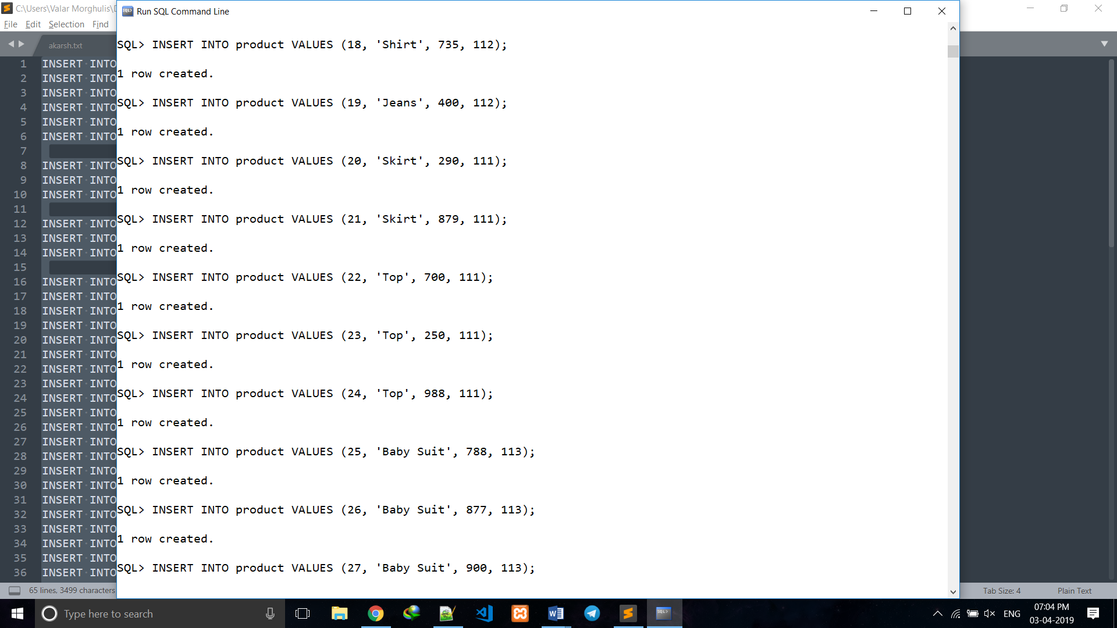

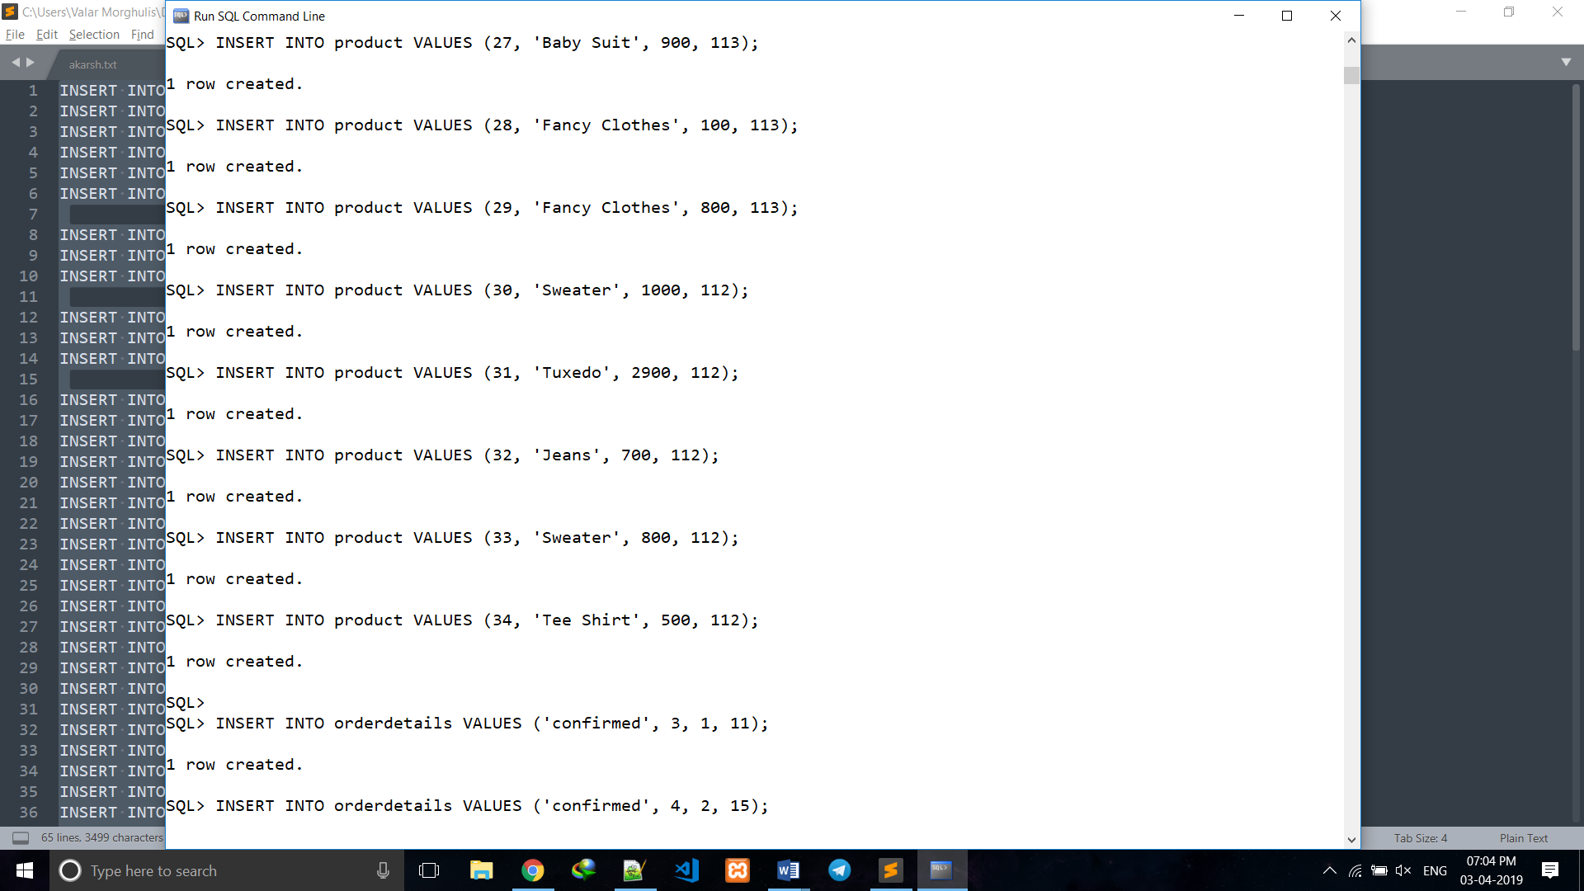

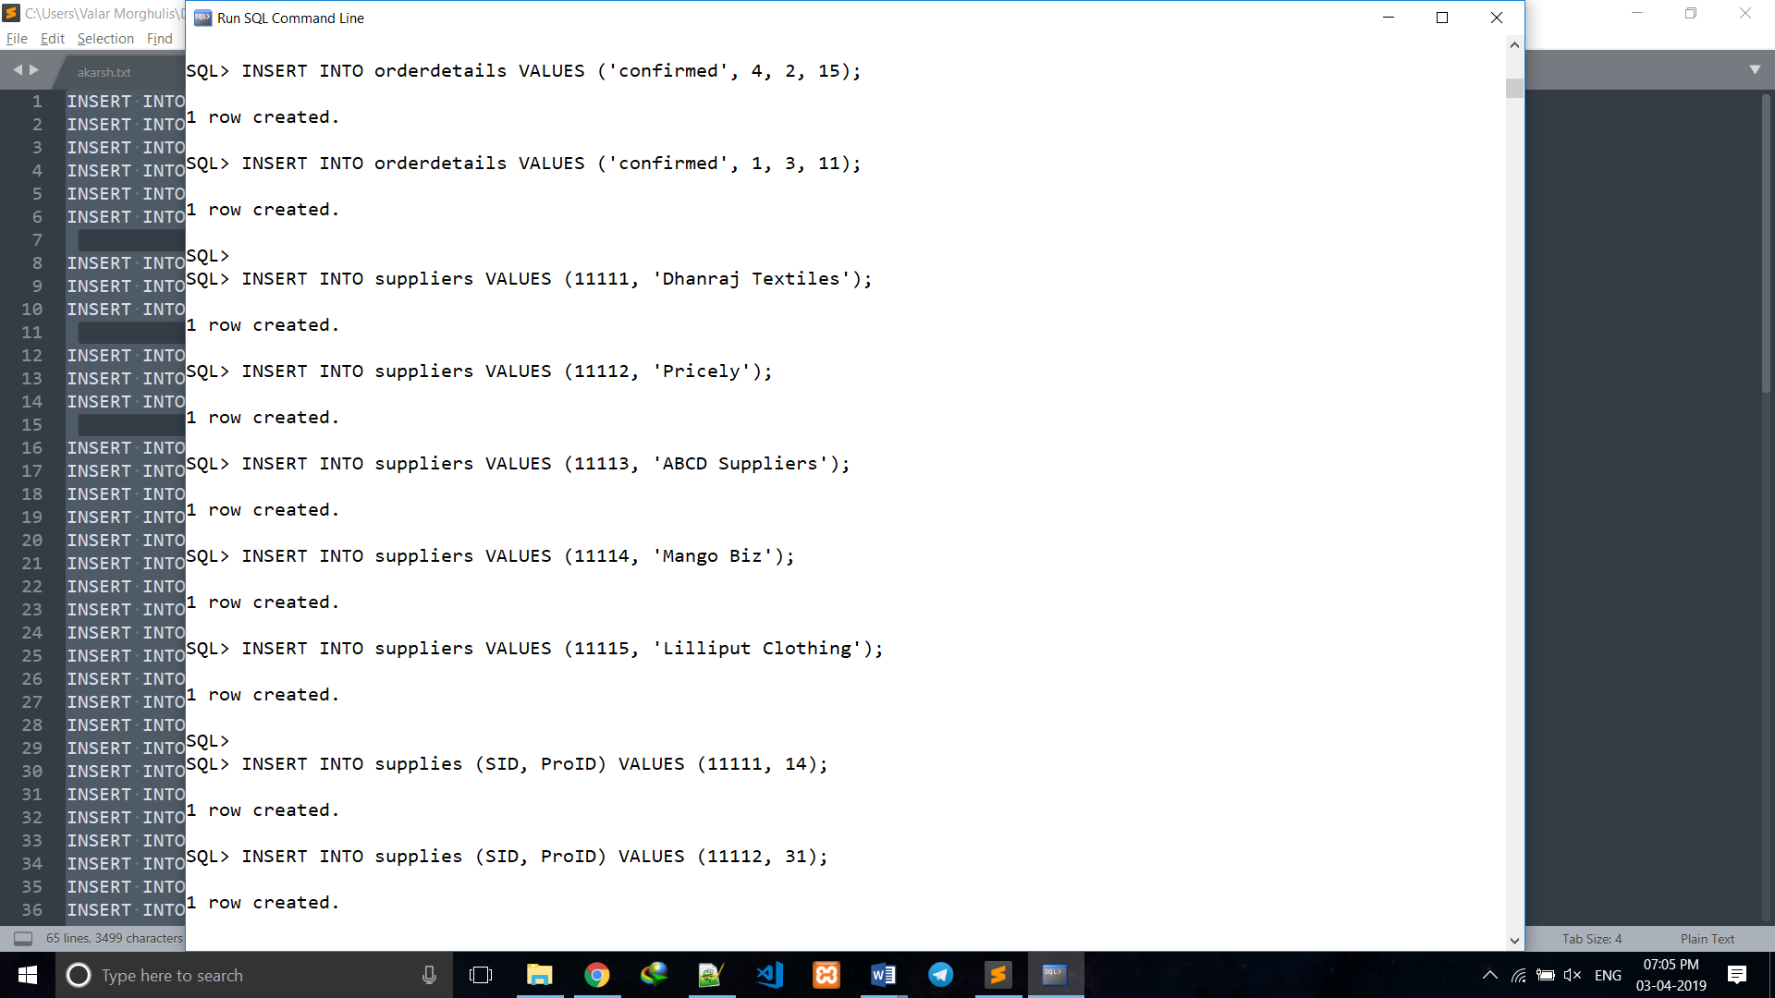

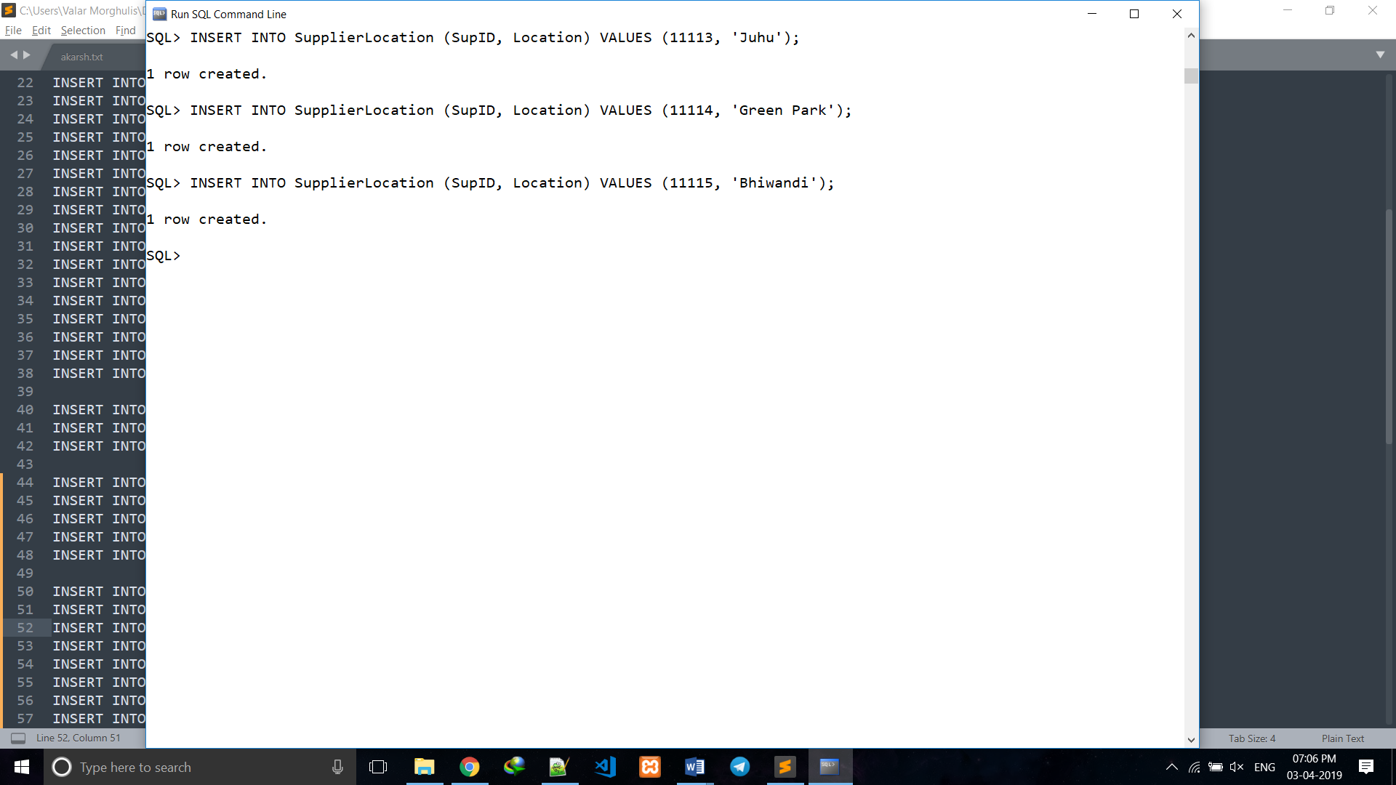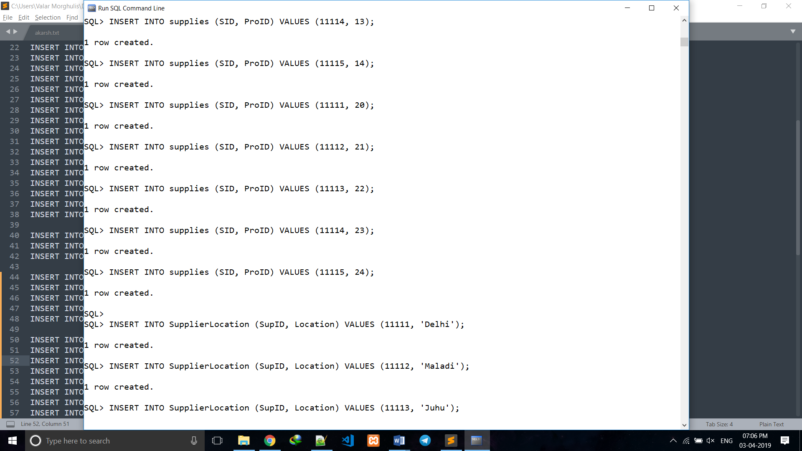

* 1. **Oracle SQL**

SQL Structured Query Language is a domain-specific language used in programming and designed for managing data held in a relational database management system (RDBMS), or for stream processing in a relational data stream management system (RDSMS). It is particularly useful in handling structured data where there are relations between different entities/variables of the data.

SQL provides statements for a variety of tasks, including:

* Querying data
* Inserting, updating, and deleting rows in a table
* Creating, replacing, altering, and dropping objects
* Controlling access to the database and its objects
* Guaranteeing database consistency and integrity

SQL unifies all of the preceding tasks in one consistent language.

* 1. **Simple Queries**

1. 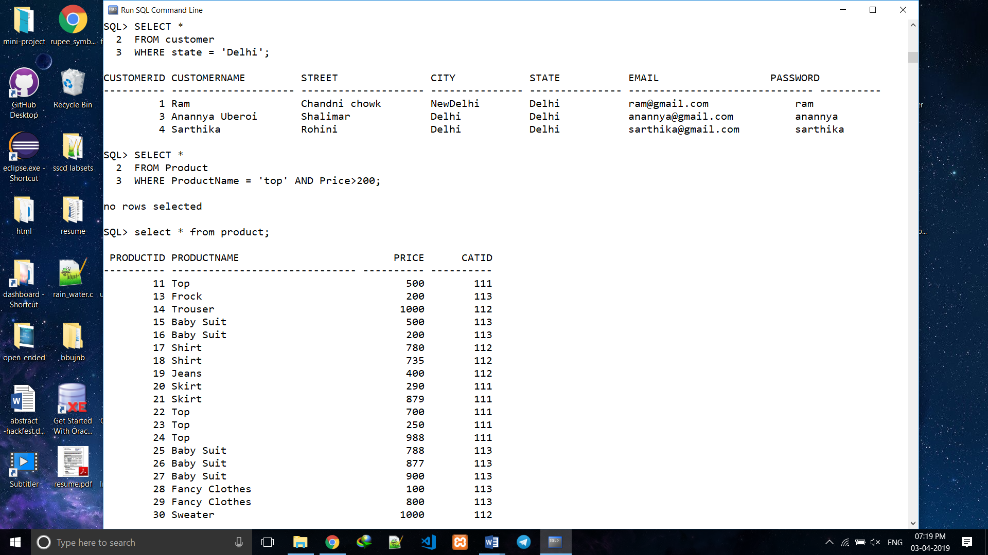Display all the customer details who lives in Delhi**.**
2. 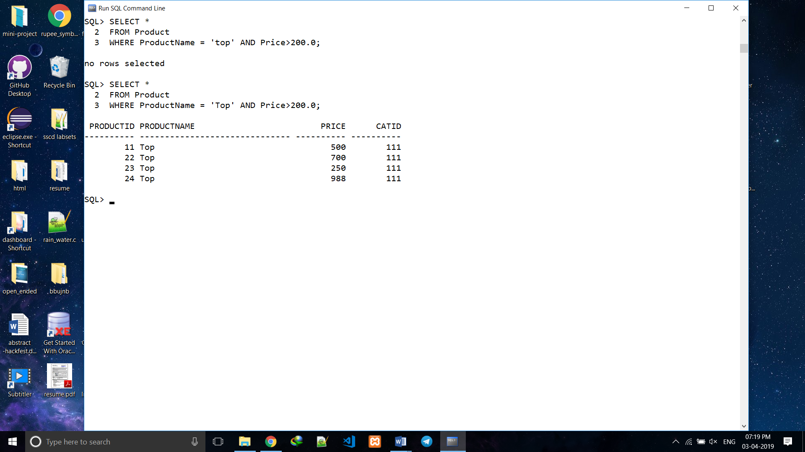Retrieve all the tops having price greater than 200 rupees from the product table.
3. Retrieve all the product name, product price from ‘Men’ category.

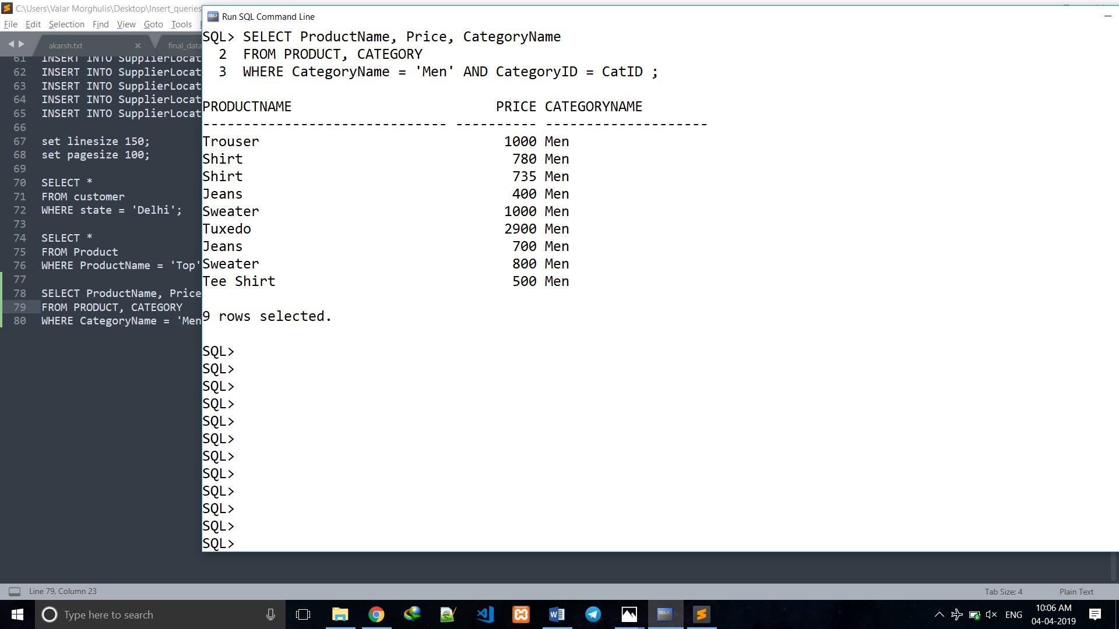

1. Increase the price of each item by 10%.

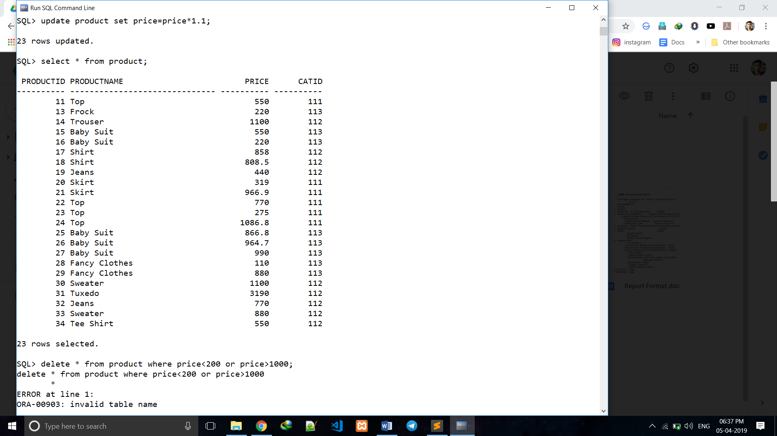

1. Add check constraint to price in product table, which should allow only positive values.

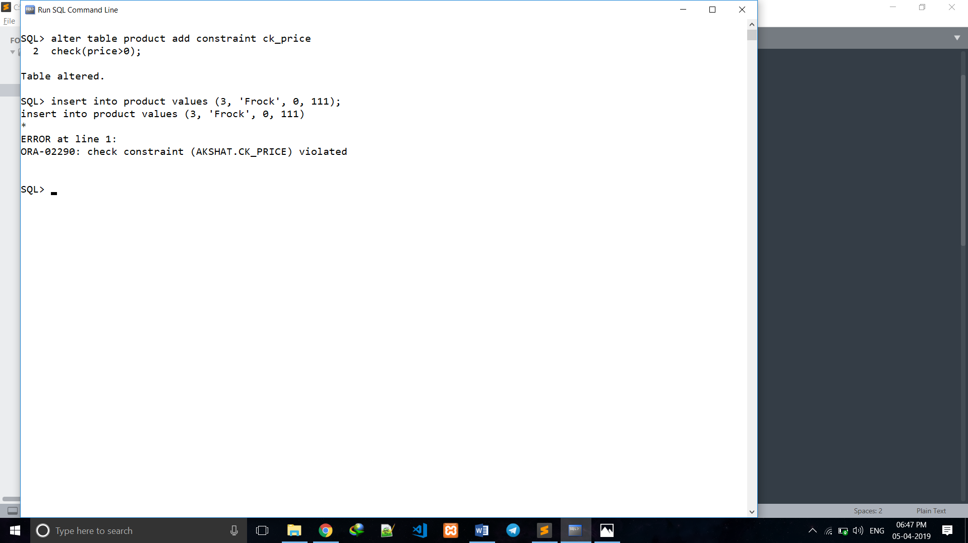

1. 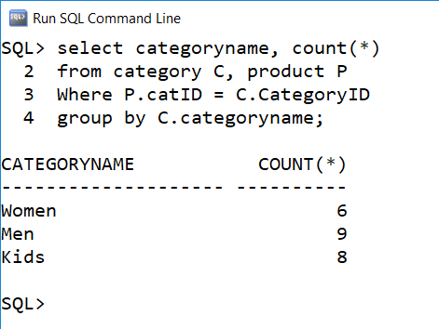Display the number of products under each category.
2. Retrieve Min and Max Order Amount.

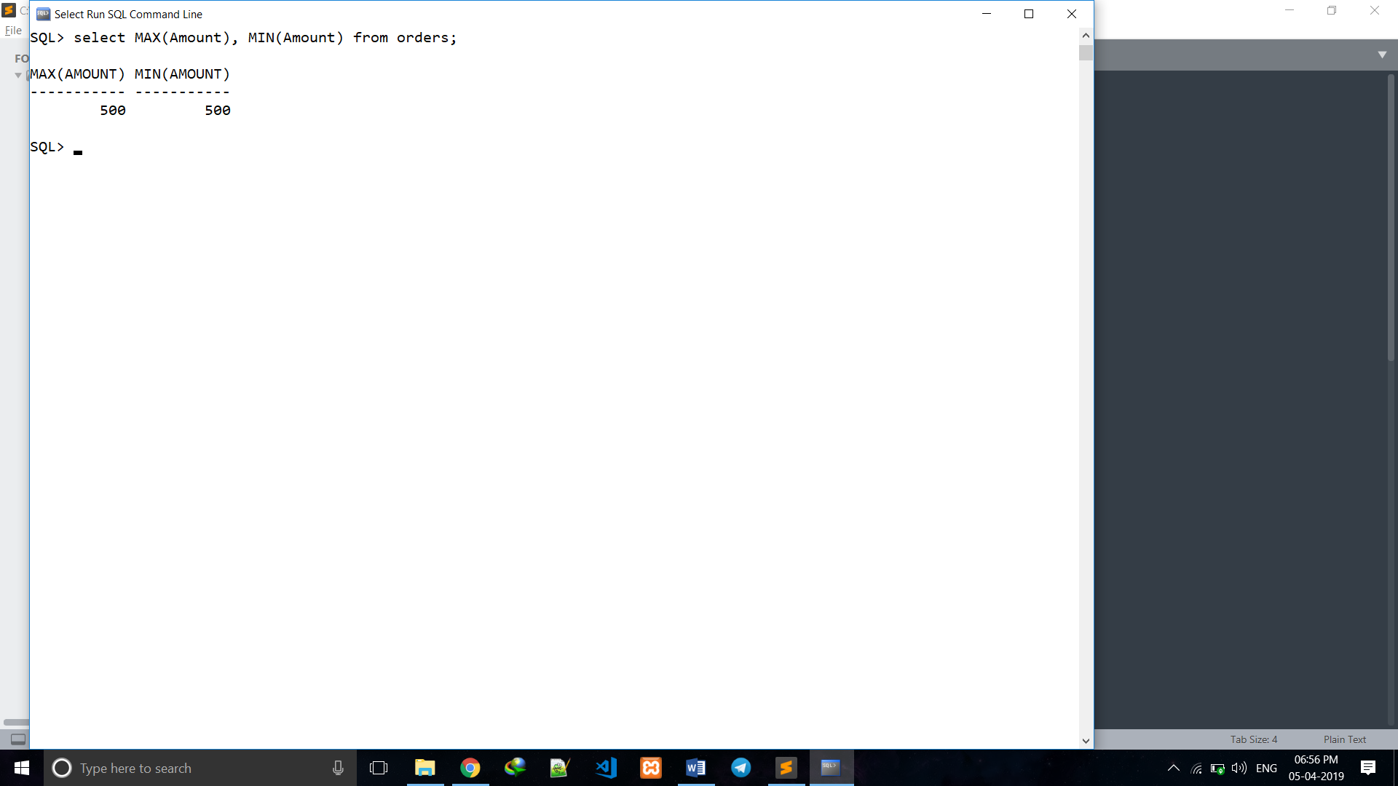

1. Produce the list of order b/w JAN 2000 to JAN 2019.
2. For all orders in orders table, show their status and quantity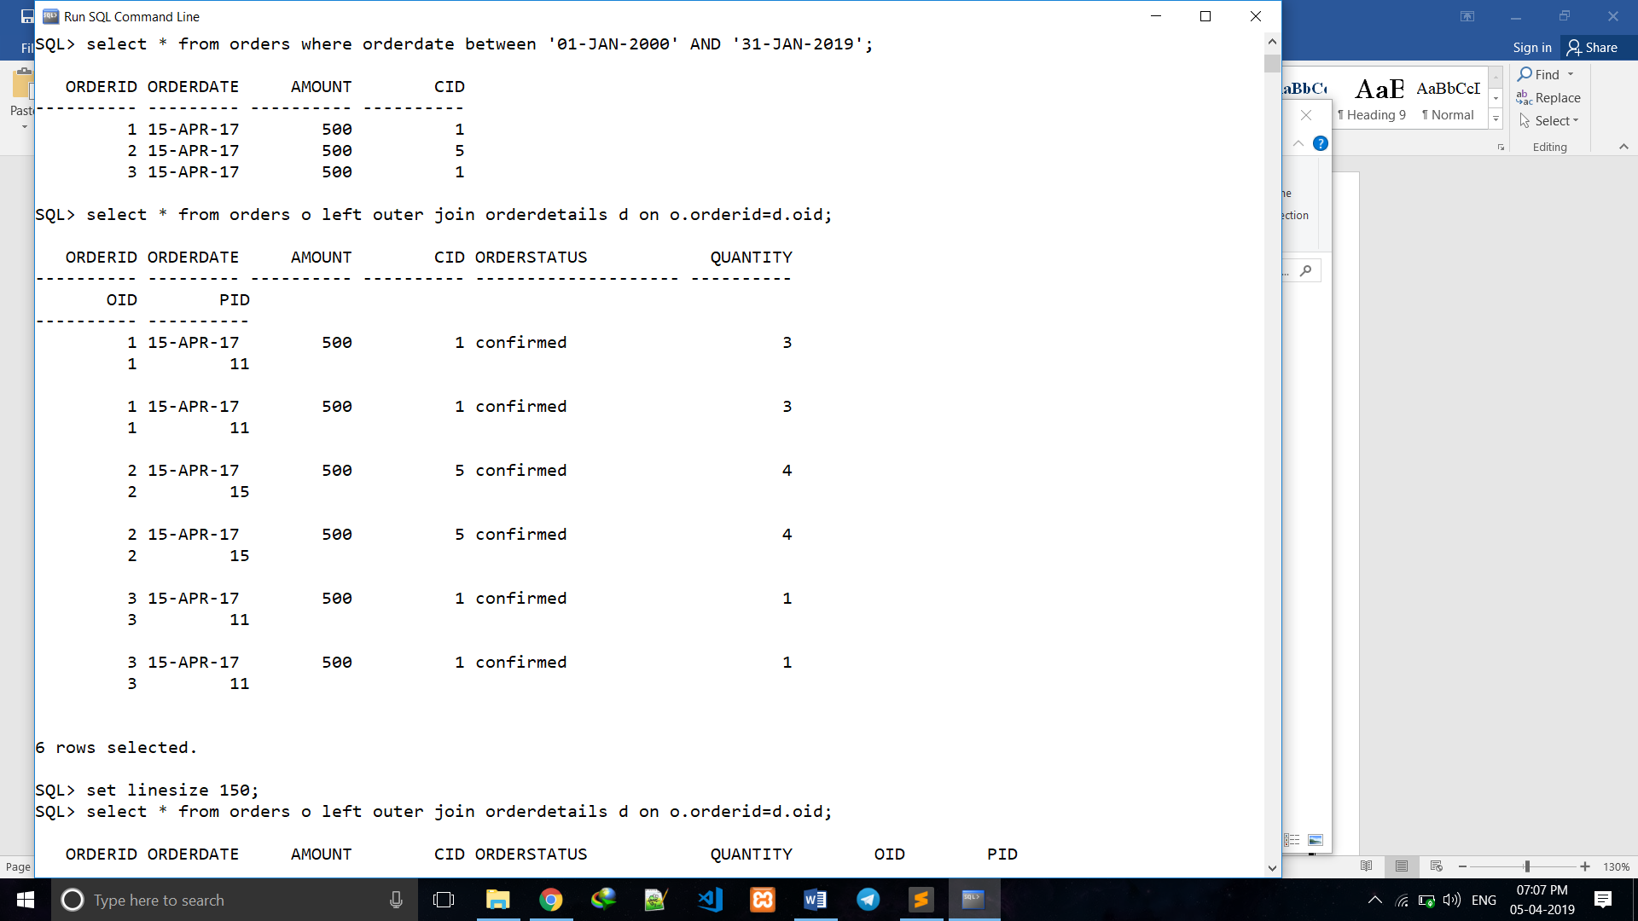.

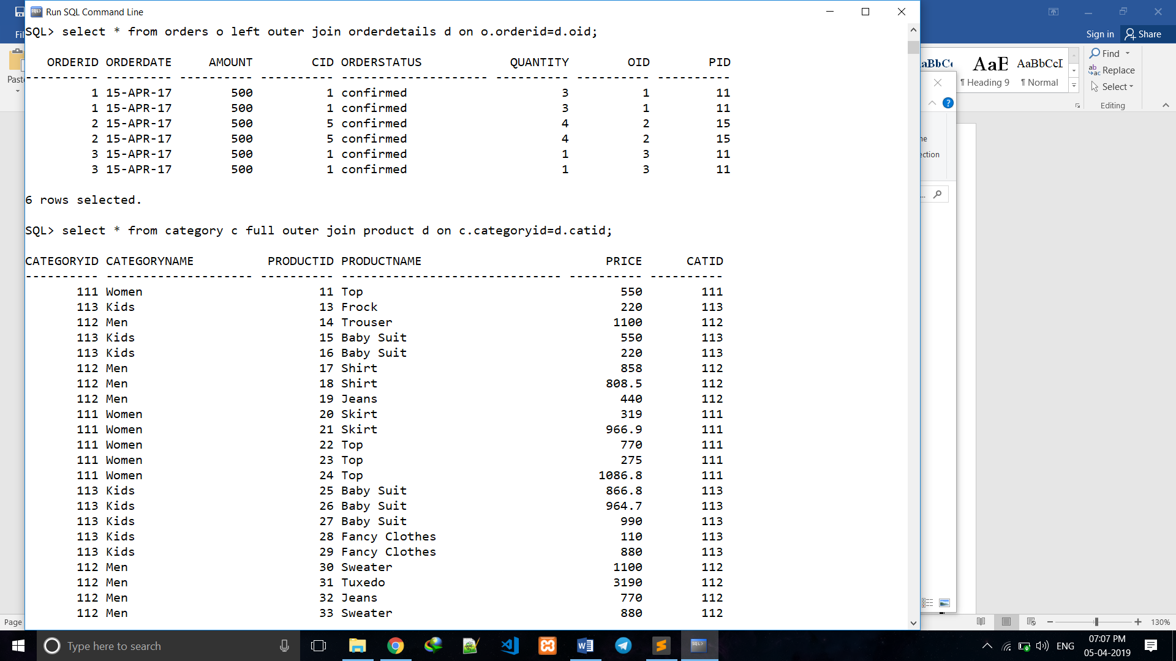

1. 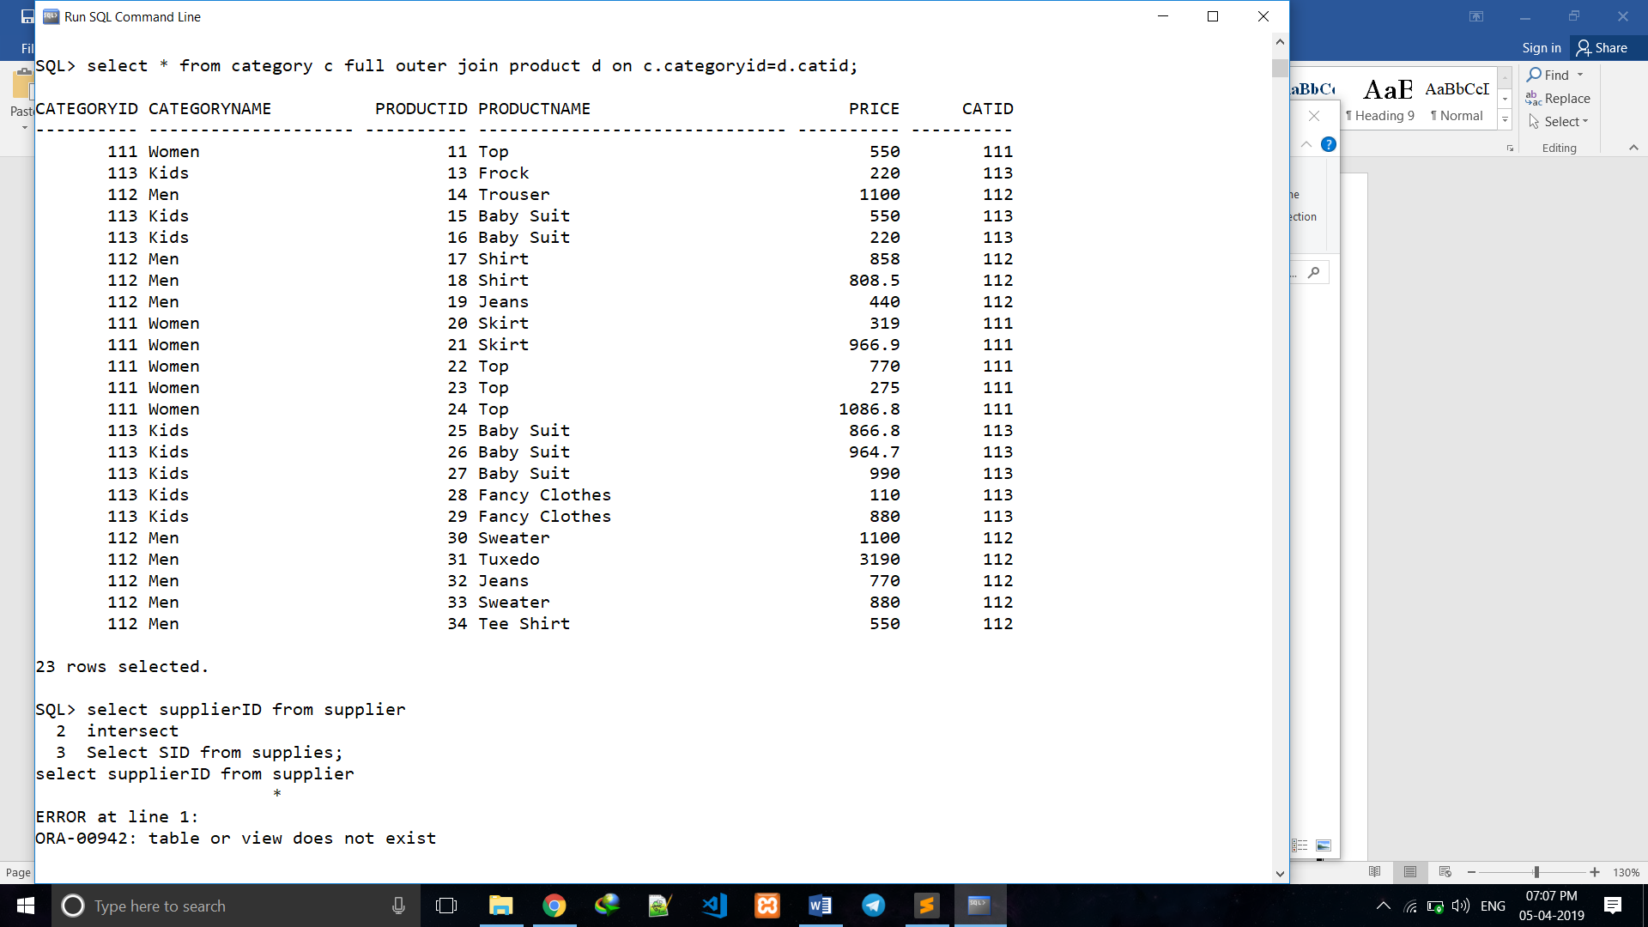For each category c list all the products that belong to c.
2. 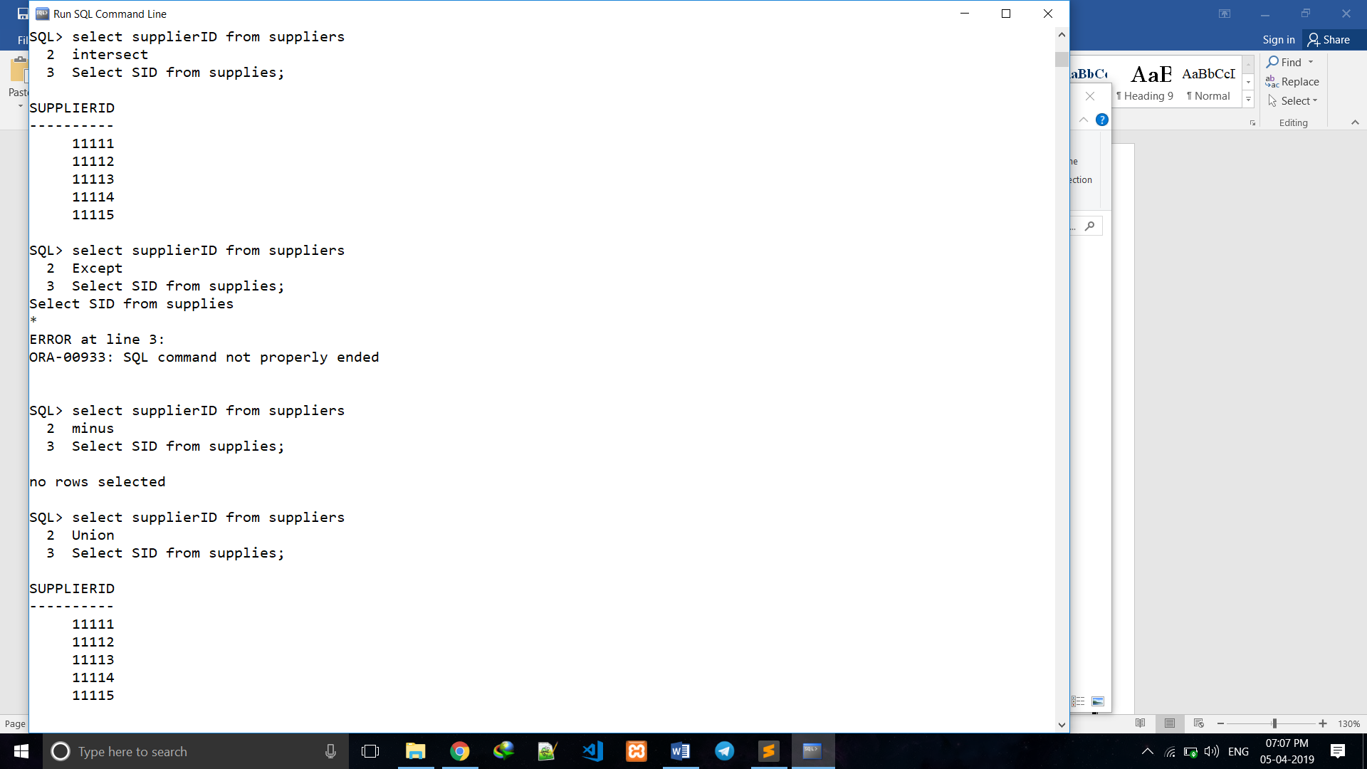Retrieve all the supplier id who supplies at least one product.
3. 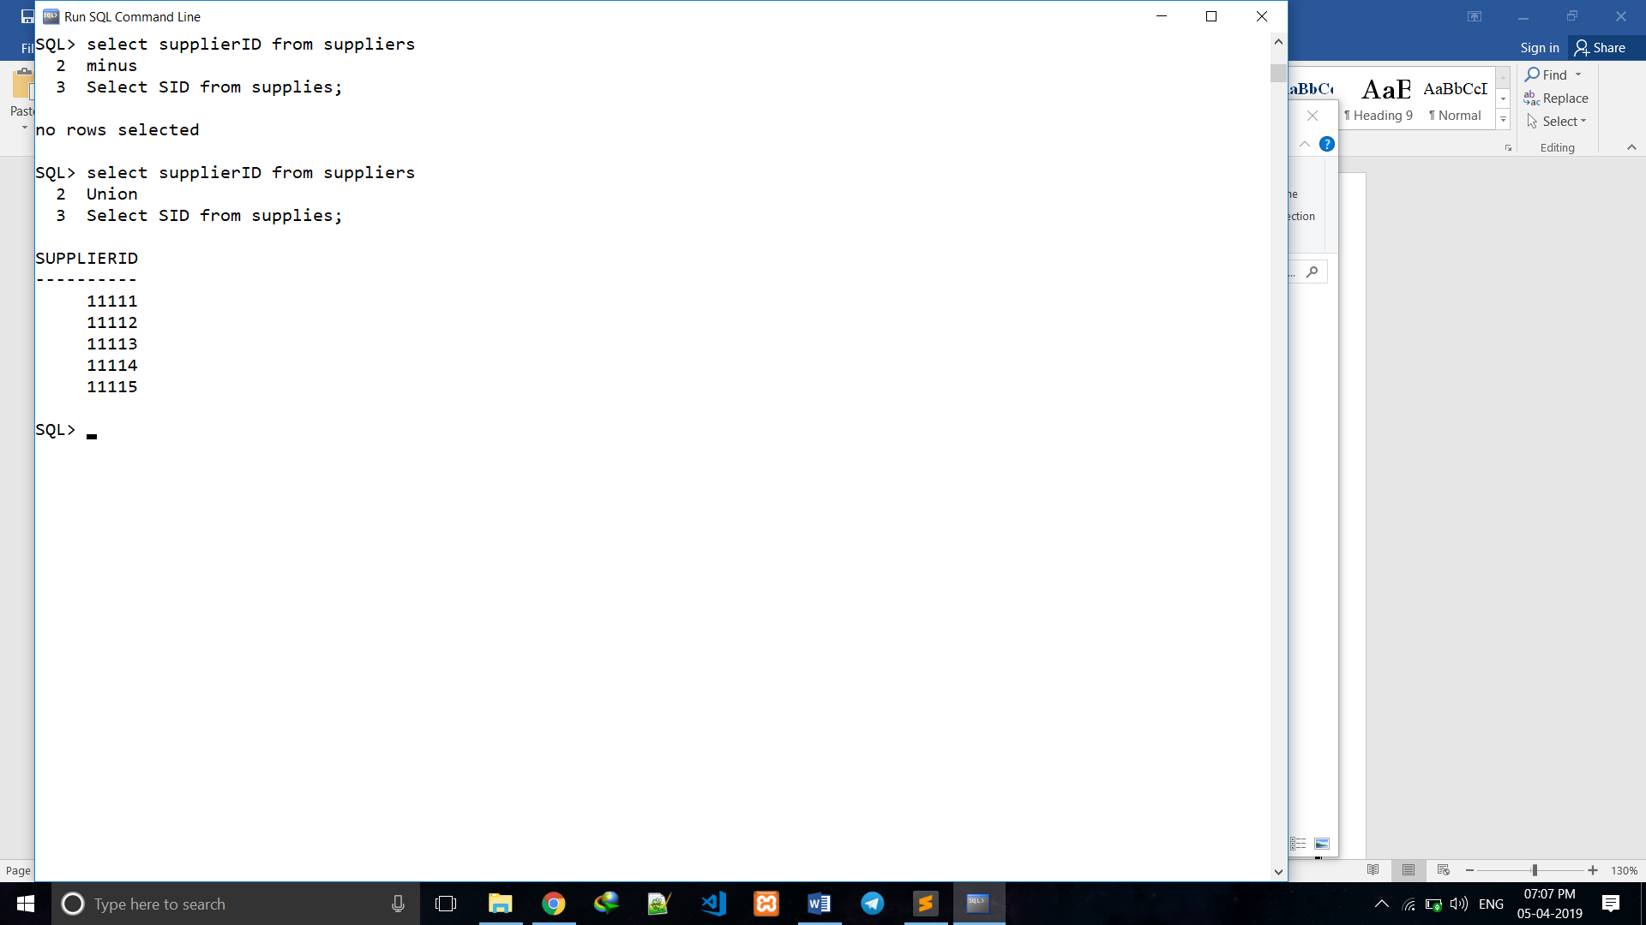Retrieve the supplier ID who do not supply any product.
   1. **Nested Queries**
4. Retrieve the supplier name and id number which supplies maximum number of products.

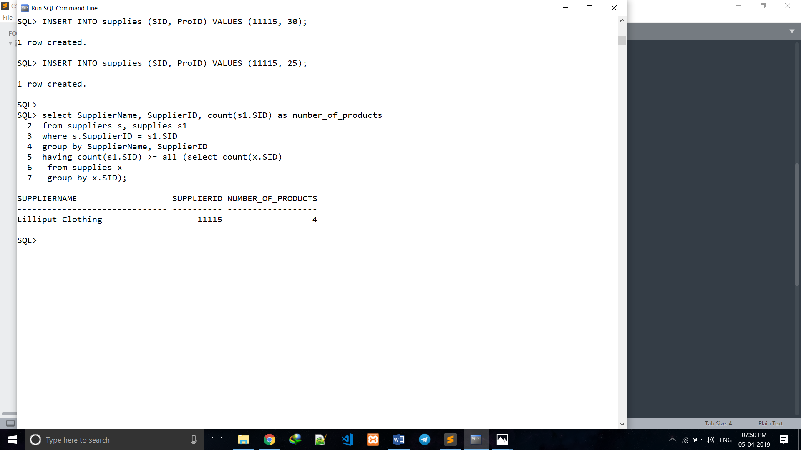

1. Retrieve the supplier names and their id number who supplies maximum number of products.

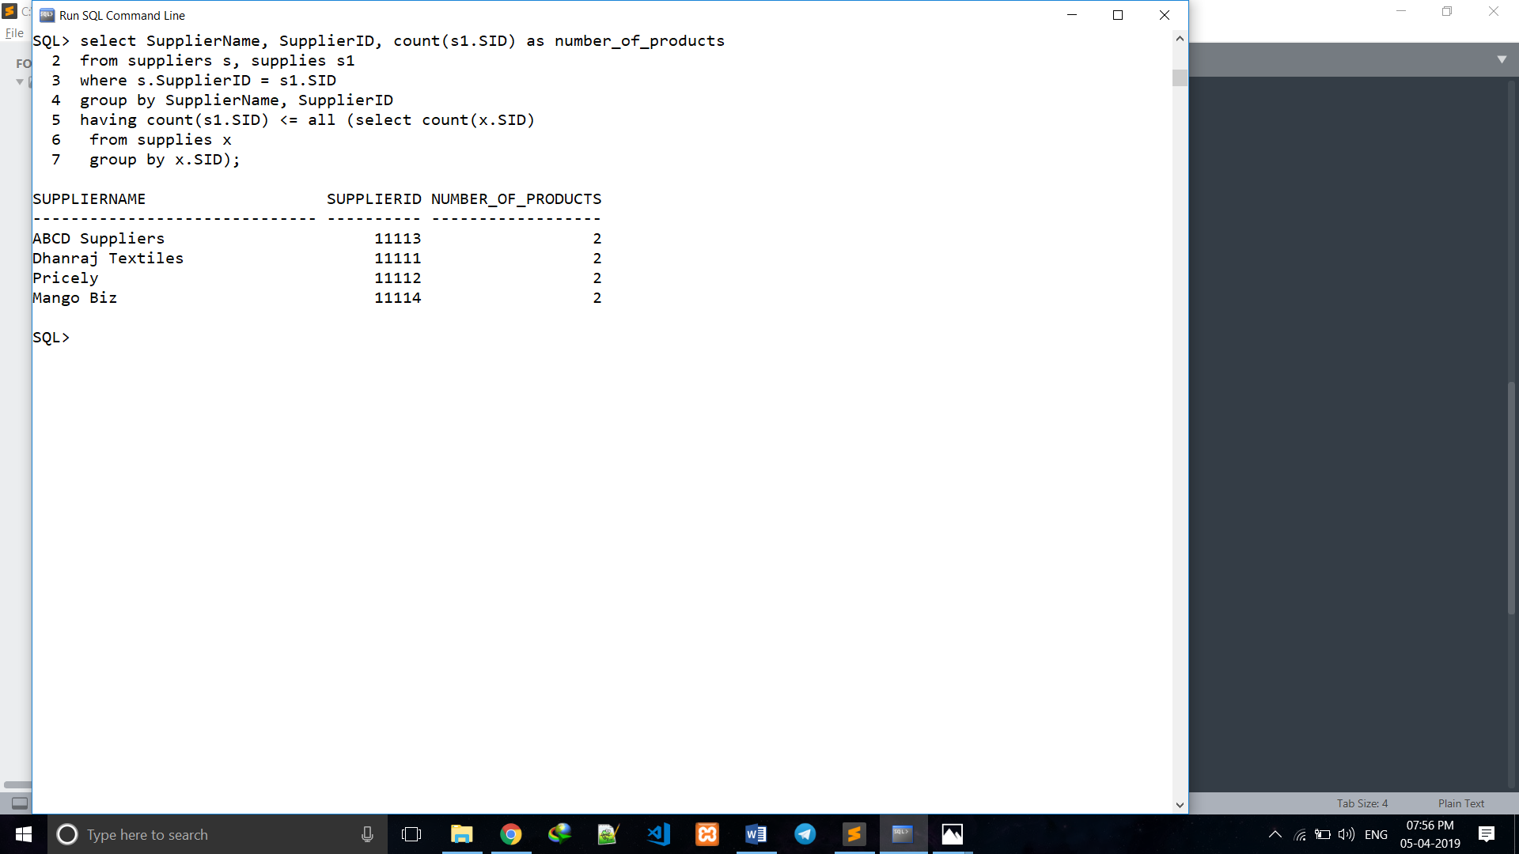

* 1. **Triggers**

1. 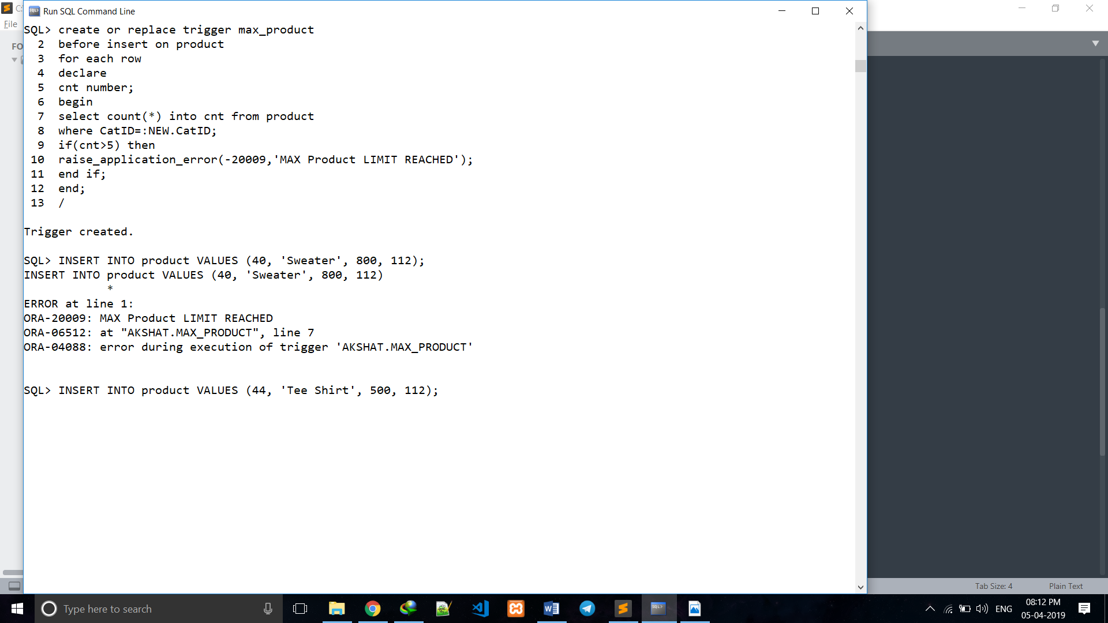Write a trigger to notify back order quantity with suitable message when product quantity in a category crosses 5.
2. 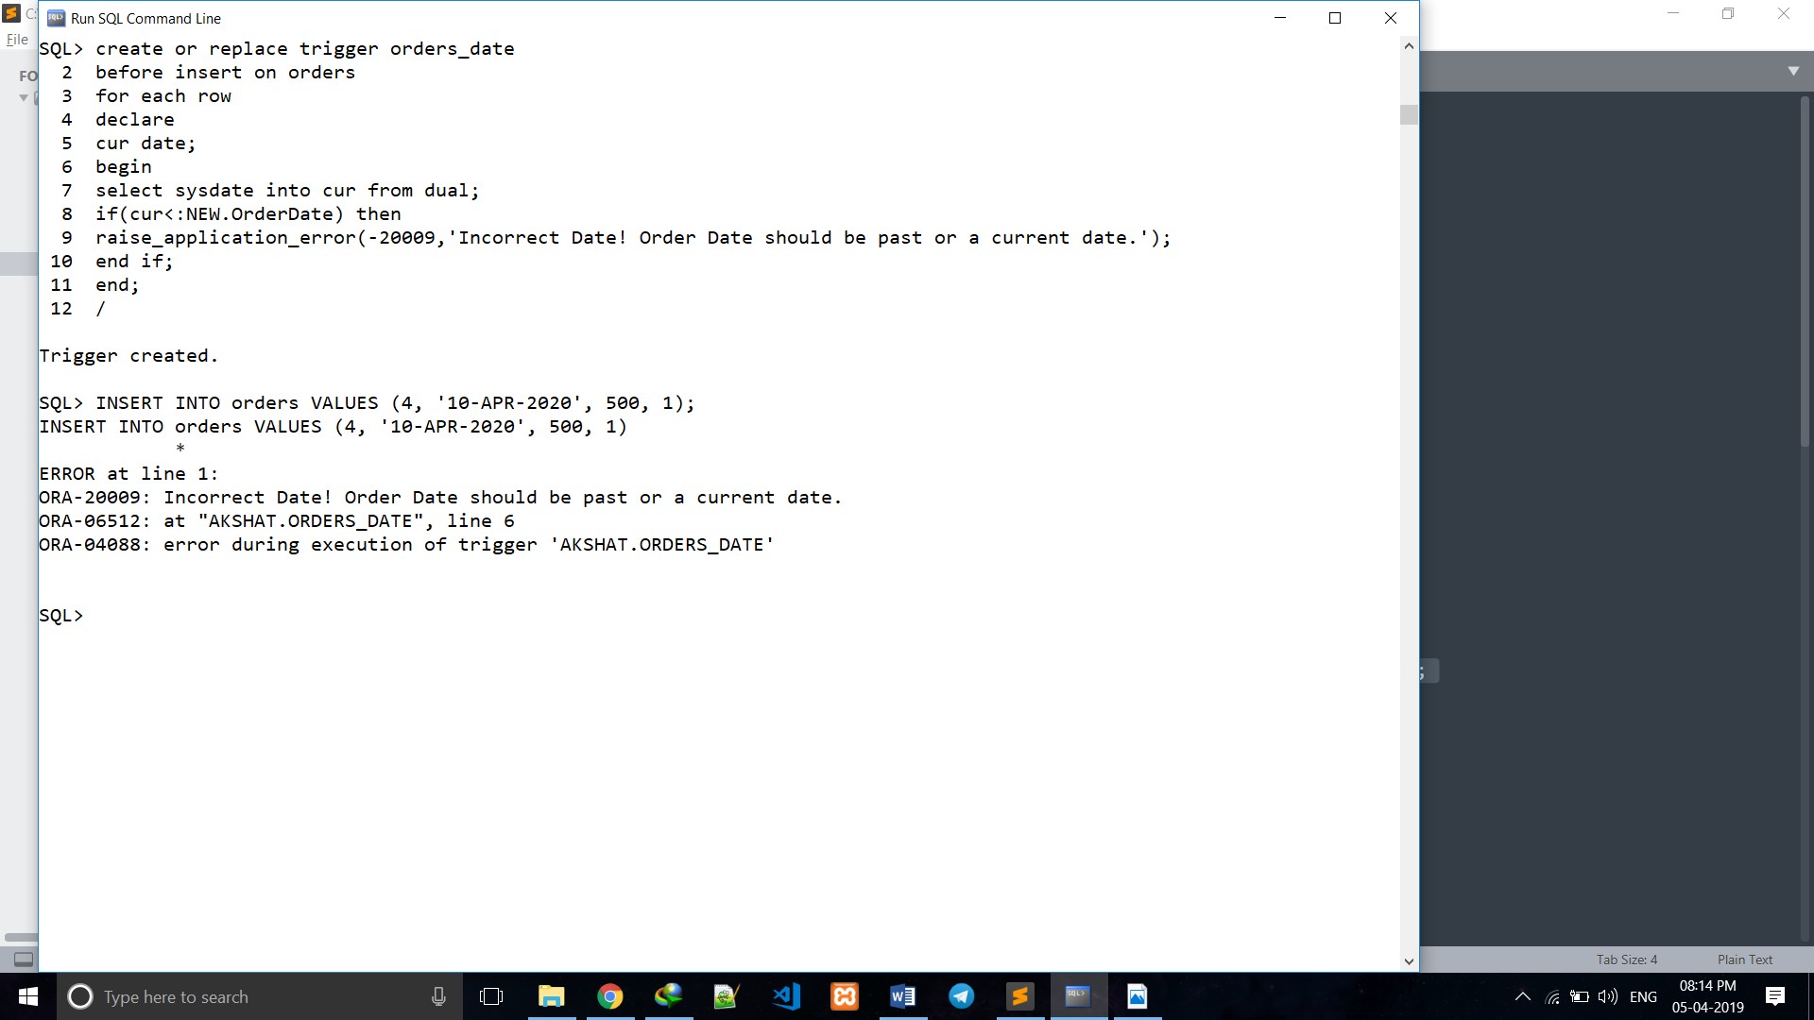Write a trigger to notify back with suitable error message when date of order crosses current date.
   1. **Stored Procedures**
3. Write a Stored procedure to display the details of order which are ordered on specific Order-Date.

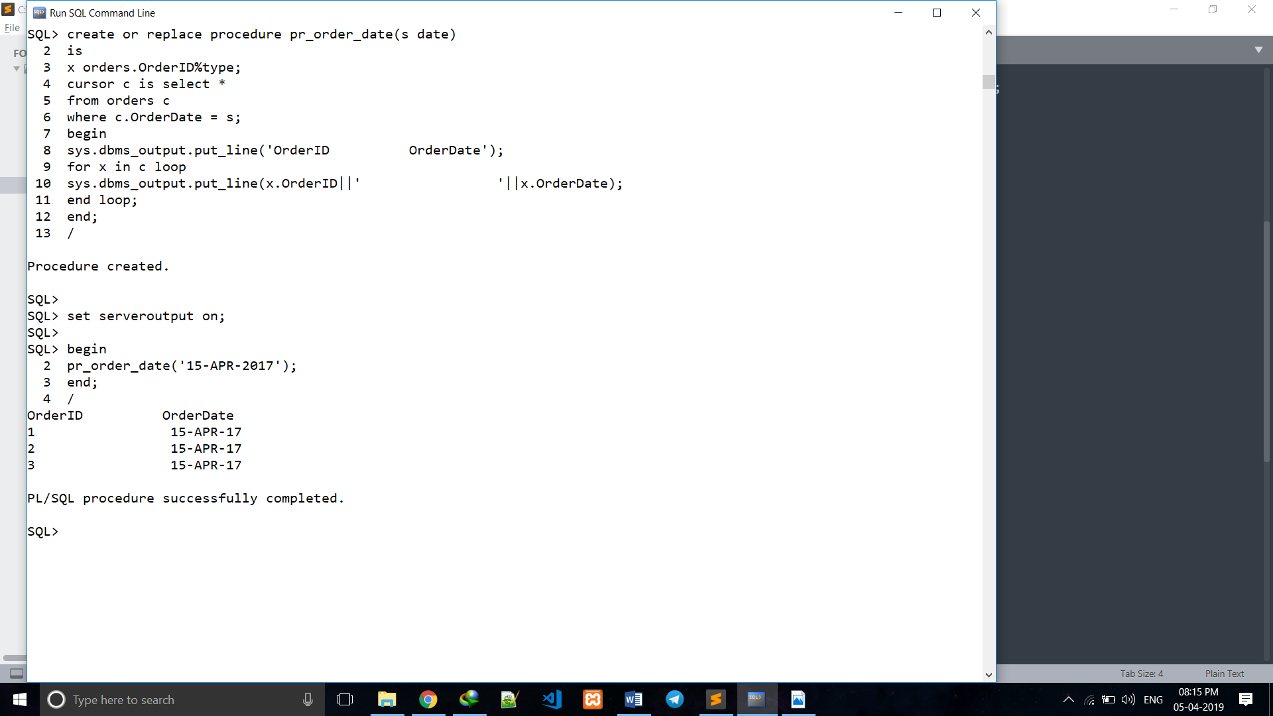

**CHAPTER 6**

**CONCLUSION**

The central concept of the application is to allow the customer to shop virtually using the

internet and allow customers to buy the items and articles of their desire from the store. The information pertaining to the products are stored in a database at the server side. The

server process the customer requirements and the items are shipped to the address submitted by the customer.

The application is designed into two modules. First, for the customers who wish to buy

the products and second is for the storekeepers who maintains and updates the information pertaining to the products.

The end user of this product is a departmental store where the application can be hosted on the web and the administrator maintains the database. The details of the items are brought forward from the database for the customer view based on the selection through the menu and database of all the products are updated ate the end of each transaction.

**CHAPTER 7**

**REFERENCES**

1. https://www.oracle.com/in/database/
2. https://en.wikipedia.org/wiki/SQL
3. https://www.codeproject.com/